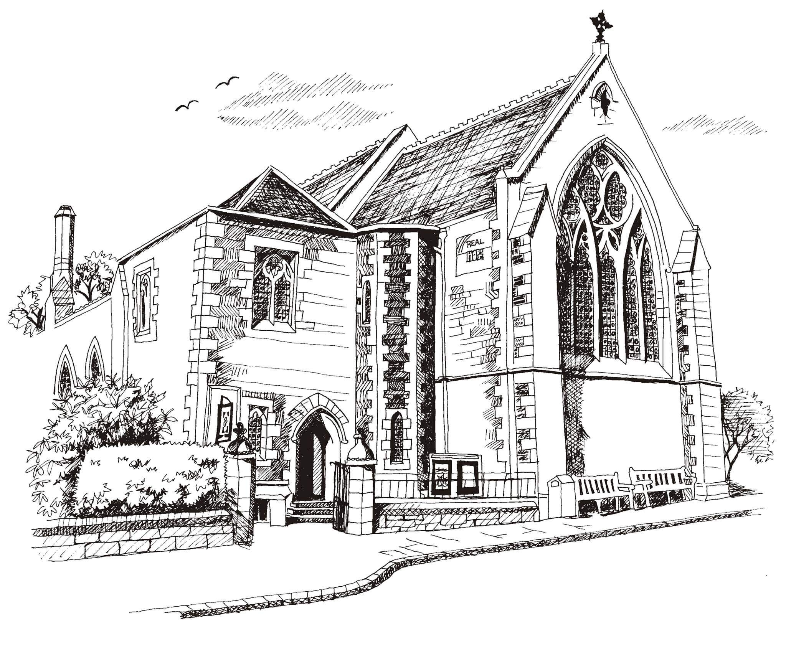**St Philip’s and St James’**

**Church Goldenacre**

**Holy Communion**

**11th September 2022 Creationtide 2**

|  |  |
| --- | --- |
| Hymn NEH 440 | Praise to the Lord |
| Liturgy of the Word | Revd Jane MacLaren |
| ***A Prayer on the death of the Queen:*** Almighty and eternal God, you uphold and govern all things both in heaven and on earth, and by your grace alone kings and queens do reign. We thank you for all the blessings which you have bestowed upon us through our late sovereign lady, Queen Elizabeth, whom you have called from this life. We thank you for the wisdom of her guidance and her love of peace, for the care and devotion with which she served her people, for the example of her gracious life. We pray that you would fill our hearts with gratitude for all these good things, and give us grace that we may use the memory of them as a perpetual call to live according to your will, for the good of all the world, and the glory of your great name, through Jesus Christ our Lord. **Amen.** | |
| Readings - Norman | Exodus 32:7-14; 1 Timothy 1:12-17 |
| Gospel – Jane M | Luke 15:1-10 |
| Reflection | George Harris |
| Intercessions | Anne P |
| Hymn MP 153 | For the fruits of his creation |
| Communion | Revd Jane Green |
| Hymn MP 428 | Lord for the Years |

**Notices for this week**

As we digest the news of the death of Her Royal Highness Queen Elizabeth II, we’ll hold a minute of slience at the beginning of our service today to give thanks for her life. We will be remembering her and our new King Charles III during our service and in our prayer time on Wednesday morning this week.

We also welcome George Harris, who will be preaching today in our second week of Creationtide.

**Dates for your diary**

**Wednesdays at 10.30 ‘**Growing with the Gospel’ – informal Bible reading, chat and prayer in church. All welcome.

**Friday 23rd September Book Group** reconvenes for the autumn in the small hall at 2.30pm. All welcome.

**Sunday 25th Sept Creationtide 4:** please stay for a talk about the work of Water Aid at coffee after the service

**Sunday 2nd October: Harvest Festival. Harvest Choir:** Rehearsals: Saturday 1st October 10am -11.30am and 10am on Sunday 2nd

If you didn’t get them last week, please pick up the sheet of ‘Eco tips’ for suggestions on eco-friendly living.

Contact Details:

Revd Jane Maclaren 07709 905528 rector@stpj.org.uk

Revd Jane Green 07914856606 [associate@stpj.org.uk](mailto:associate@stpj.org.uk)

We’ve been updating the Website: [www.stpj.org.uk](http://www.stpj.org.uk)

You can now download the weekly service sheet from the ‘latest’ section on the front page.

Scottish Liturgy 1982 – Ordinary Time St James Goldenacre Registered Charity SC000910