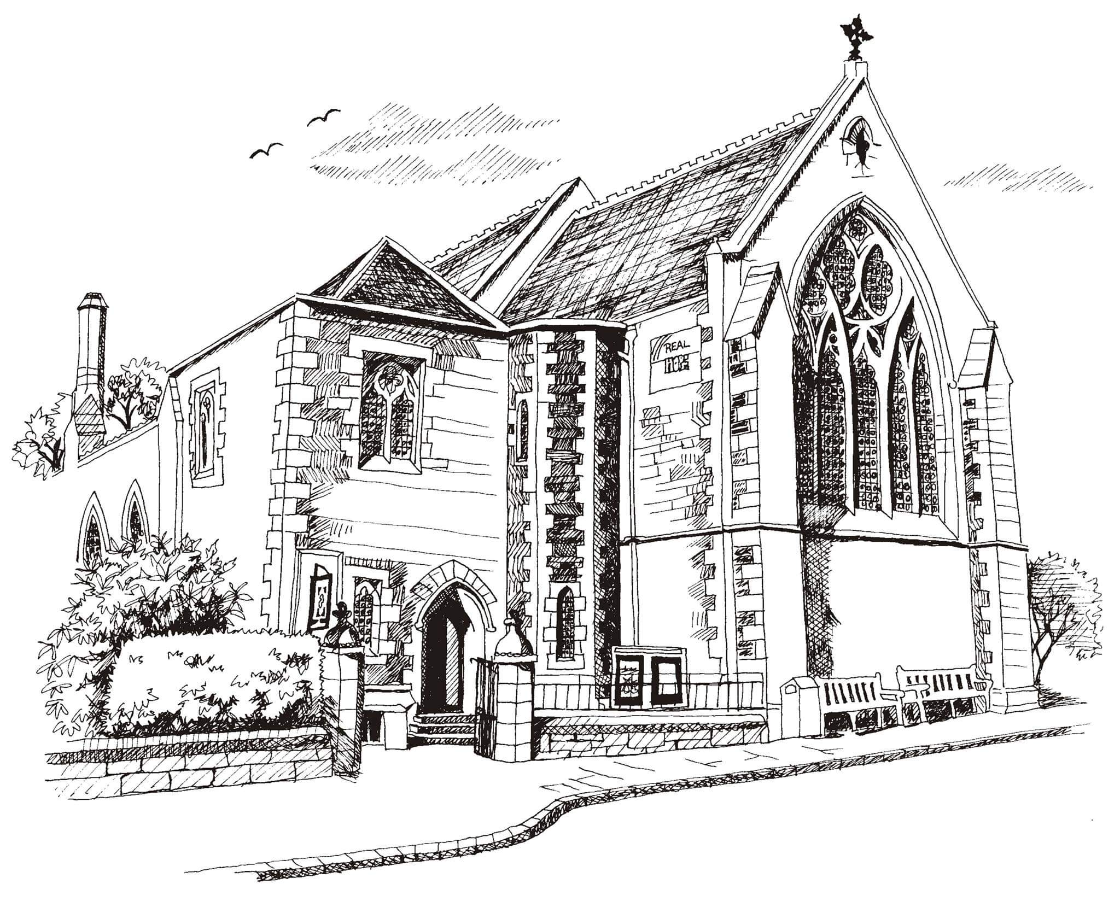
St Philip’s and St James’
Church Goldenacre

Holy Communion
4th September 2022 Creationtide 1

Hymn NEH 263 | All creatures of our God and king
Liturgy of the Word | Douglas
Collect for Creationtide
God Most High, maker of heaven and earth, you created humankind in your own image and entrusted the whole world to human care: give us grace to serve you faithfully, that we might be trustworthy stewards of your creation, through Jesus Christ our Lord, who lives and reigns with you and the Holy Spirit, one God, now and for ever. Amen.
Readings - Rachel | Deuteronomy 30:15-20  Philemon 1-21
Gospel - Duncan | Luke 14: 25-33
Reflection | Revd Dr Duncan MacLaren
Intercessions | Robert
Hymn NEH 285 | For the beauty of the earth
Communion | Revd Jane MacLaren
Hymn NEH 427 | O praise ye the Lord

Scottish Liturgy 1982 – Ordinary Time
St James Goldenacre Registered Charity SC000910
Website :www.stpj.org.uk
Notices:
Today we begin the Season of Creationtide. Over the next 5 weeks we’ll be thinking about the beautiful planet that God has made, how we enjoy it and steward it well. Please use the ‘Eco tips’ on the A4 sheet for some initial inspiration. We’ll be having a variety of speakers during the season to help us think through some of the issues. With thanks to the Eco Group for all their input.

Dates for your diary

Wednesdays at 10.30 ‘Growing with the Gospel’ – informal Bible reading, chat and prayer in church. All welcome.

Friday 23rd September Book Group reconvenes for the autumn in the small hall at 2.30pm. All welcome. For more information please see Robert Greenshields.
Sunday 2nd October: Harvest Festival.
Harvest Choir: We will be singing “For the beauty of the earth” by John Rutter. Copies available from Jen beforehand for practice. Rehearsals: Saturday 1st October 10am -11.30am and 10am on Sunday 2nd for 30 minutes before the service. The practices are open to all. See you soon!
Advent Choir: rehearsals on Weds evenings in November. More info to follow. Speak to Douglas if you’re interested.
AGM: 11th December after the service

Contact Details:
Revd Jane Maclaren 07709 905528 rector@stpj.org.uk
Revd Jane Green 07914856606 associate@stpj.org.uk

