Notices:
Today we remember all those who have died in wars around the world and we pray for peace. There will be a period of silence at 11am for our own quiet reflections.
Next Sunday 20th will be our last in church for a while before we move to the hall for winter on 27th. Please join us for the next 2 weeks as we make the move together, celebrate Christ the King and mark the beginning of Advent. We will no doubt learn and grow from being ‘the other side of the wall’ as we make this journey as a congregation.
Foodbank Donations: please leave items in the white boxes for monthly uplift. Check the list on the boxes for what to bring.
New Scots Christmas Appeal (ECM) Donate to the Christmas hamper appeal by cheque to St. Philip’s &amp; St. James’ Church – mark envelope ‘New Scots Christmas Appeal’ or bank transfer: ‘St Philips and St James Church’ s/c: 80 02 33 acct: 00787069. Description: ‘New Scots’.
Flower Team Helpers needed: No experience necessary – just fill a vase! See noticeboard to sign up or speak to Toni or Suzannah.
Book Club: Next meeting is on 14th November at 2.30pm at Anne Pankhurst's house. We will be discussing ' The Underground Railway' by Colson Whitehead. All are welcome. Come and join us!

Dates for your diary
Advent Choir: Weds 9th, 16th and 23rd at 7.30 - 9pm in the hall, for singing in Advent services. Refreshments provided. All welcome.
Wednesdays 10.30am ‘Growing with the Gospel’ – informal Bible
reading, chat and prayer in church. All welcome.
Sunday 20th November: Christ the King
Advent Sunday 27th November: Worship in the Hall
Sunday 11th December: AGM after the service Contact Details

Revd Jane Maclaren 07709905528 rector@stpj.org.uk
Revd Jane Green 07914856606 associate@stpj.org.uk

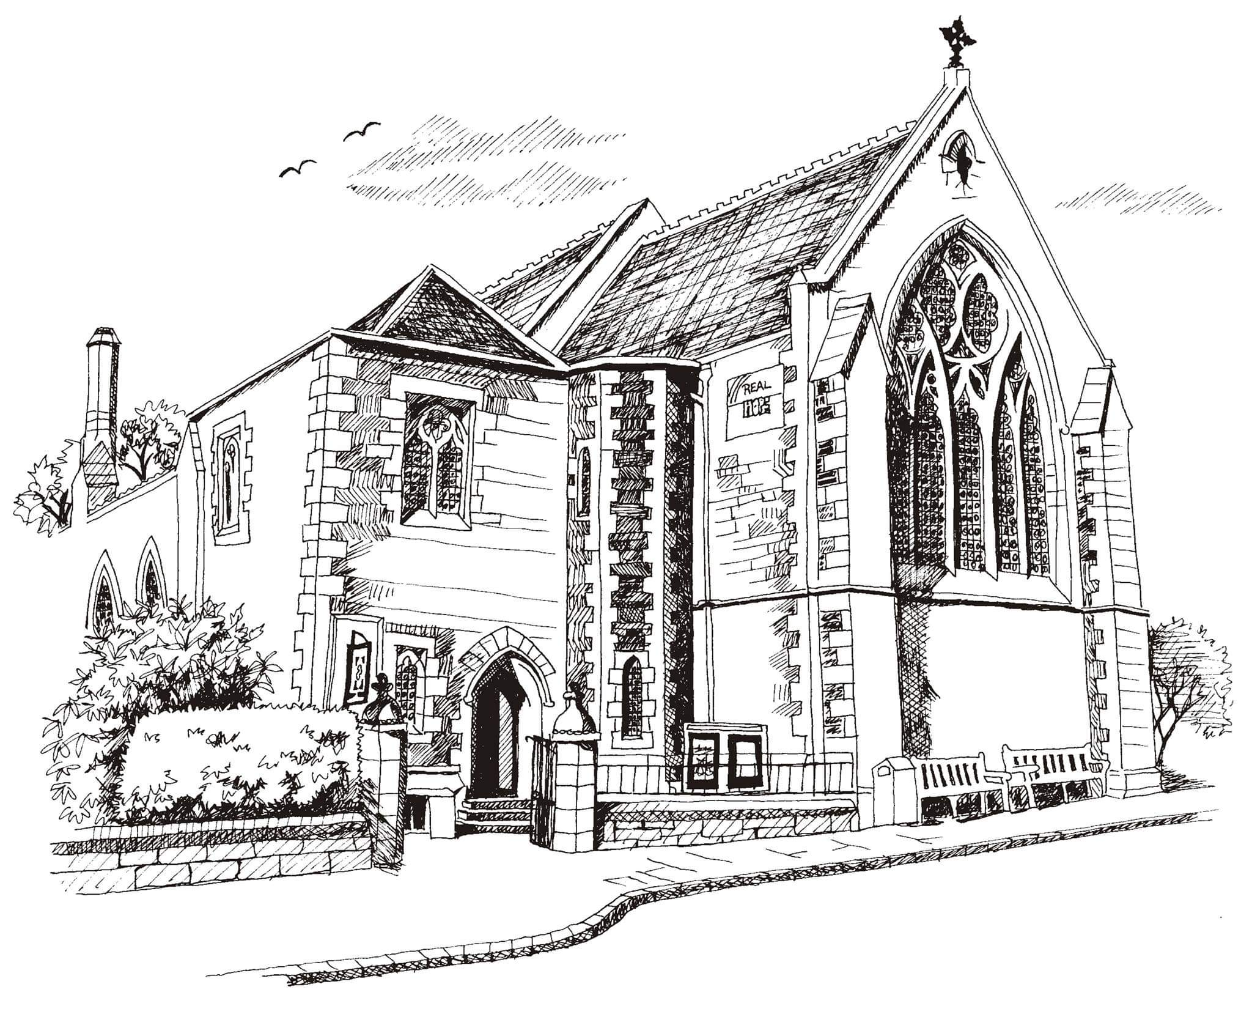
St Philip’s and St James’
Church Goldenacre

Holy Communion
13th November 2022
Remembrance Sunday

Hymn 494 | O God our help in ages past
Act of Remembrance
Liturgy of the Word | Jenny
Collect for Remembrance
O God, it is your will to hold both heaven and earth in a single peace. Let the design of your great love shine on the waste of our wraths and sorrows, and give peace to your Church, peace among nations, peace in our homes, and peace in our hearts; through your Son Jesus Christ our Lord, who lives and reigns with you and the Holy Spirit, one God, now and for ever.
Readings – Bill | Job 19.21-27  1 Corinthians 15.51-57
Gospel – Jane G | John 6.37-40
Reflection | Anne Pankhurst
Intercessions | Rosemary King
Hymn 144 | Dear Lord and Father of mankind
Communion | Rev Jane Green
Hymn 474 | Now thank we all our God
Prayer after Communion
Eternal God, comfort of the afflicted and healer of the broken, you have fed us at the table of life and hope. Teach us the ways of gentleness and peace, that all the world may acknowledge the kingdom of your Son Jesus Christ our Lord.

Blessing
The God of peace, who brought again from the dead our Lord Jesus, that great shepherd of the sheep, through the blood of the eternal covenant, make you perfect in every good work to do his will, working in you that which is well-pleasing in his sight; and the blessing of God almighty, the Father, the Son, and the Holy Spirit, be among you and remain with you always.

Scottish Liturgy 1982 – Ordinary Time
St James Goldenacre Registered Charity SC000910
We remain standing
Act of Remembrance
Let us remember before God and commend to God’s mercy and keeping those who have died for their country in war; those whom we knew and whose memory we treasure; and all who have lived and died in the service of humankind. Especially we remember those known to us personally and those of this congregation, and all who will be injured or killed this day as a result of conflicts across the world.

‘They shall grow not old as we that are left grow old.
Age shall not weary them, nor the years condemn.
At the going down of the sun
and in the morning, we will remember them’
We will remember them

The Silence

Almighty and eternal God, from whose love in Christ we cannot
be parted, either by death or life: Hear our prayers and
thanksgivings for all whom we remember this day; fulfil in them the purpose of your love; and bring us all, with them, to your eternal joy; through Jesus Christ our Lord. Amen.

Lord God, we pledge ourselves to serve you and all people in the cause of peace, for the relief of want and suffering, and for the praise of your name. Guide us by your Spirit; give us wisdom; give us courage; give us hope; and keep us faithful now and always. Amen.

