St Philip’s and St James’ NOTICE of Annual General Meeting
The AGM will be held on Sunday 11th December 2022 in church immediately after the 11am Service.
Everyone is welcome to attend.
Posts currently available for election are:
People’s Warden, Lay Representative and Alternate Lay Representative, and two elected vestry members.
If you would like to stand,
please see Jane Mac for a list of Vestry responsibilities.
Nomination forms (to be proposed and seconded) will be available in church from
Sunday 27th November 2022
Signed nomination forms should be returned to
Jane M or Jane G by noon on Friday 9th December.
Anyone who is on our Contacts List, has received communion at St James’ at least once in the previous 12 months and are 16 or over is entitled to vote.

Any other competent business (questions or issues for discussion) must be notified to Jane Mac by
Sunday 4th December at the latest.

Contact details:
Revd Jane Maclaren 07709905528 rector@stpj.org.uk
Revd Jane Green 07914856606 associate@stpj.org.uk

For more information about the life of St Philips and St James Church, see our website: www.stpj.org.uk
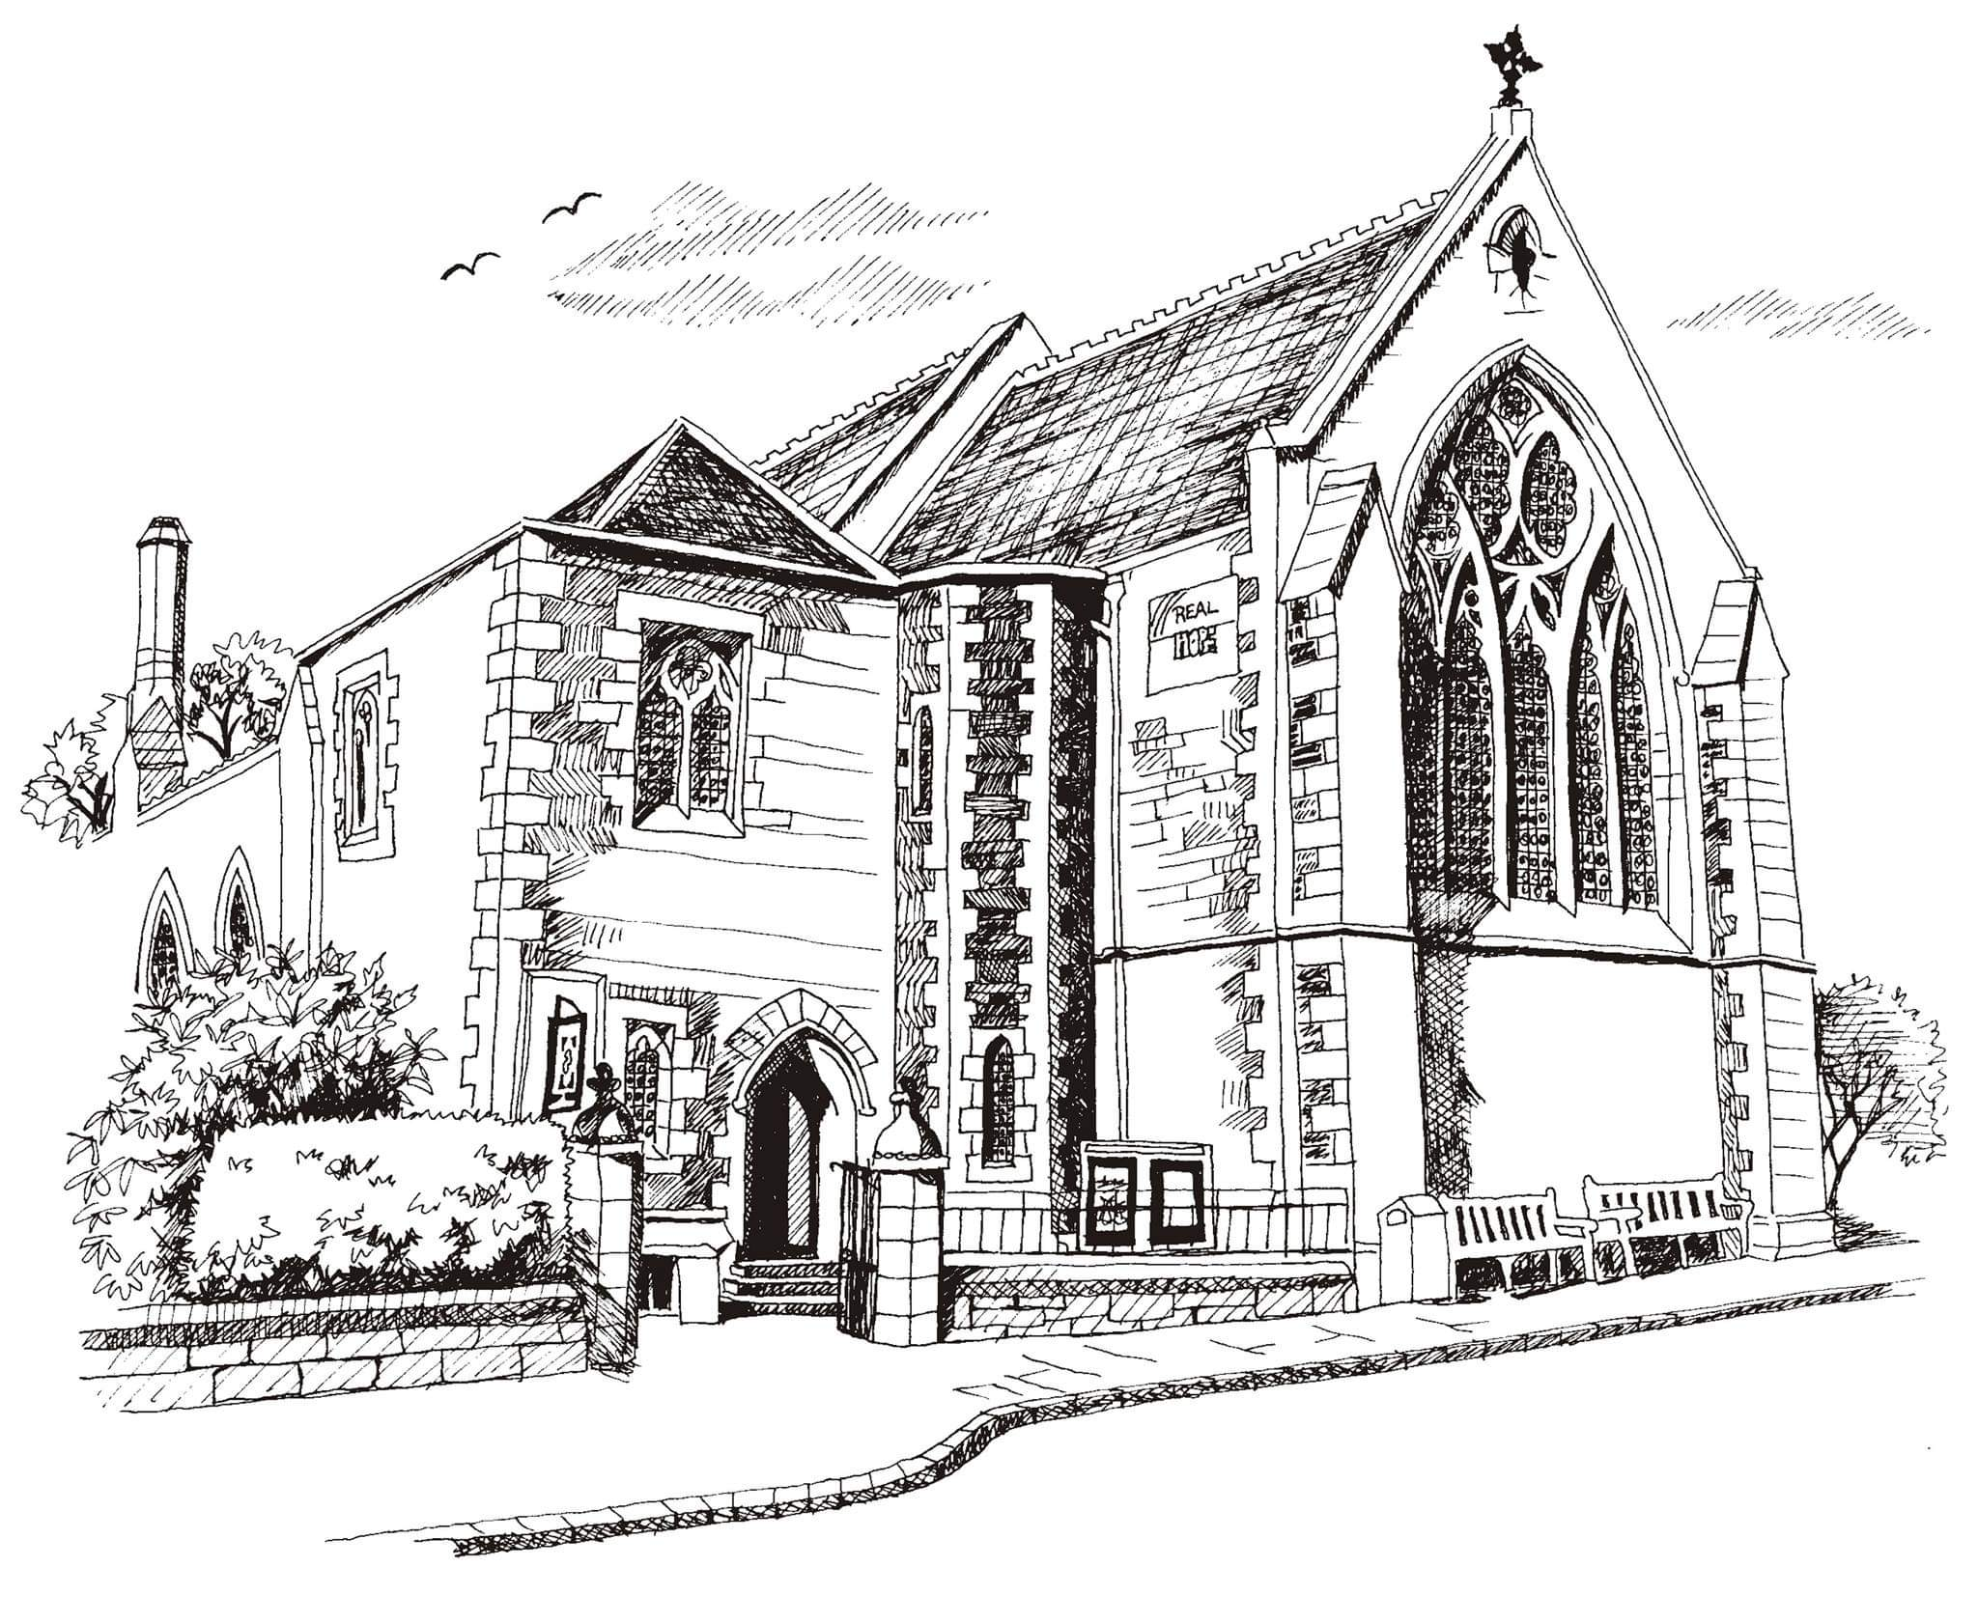
St Philip’s and St James’
Church Goldenacre

Holy Communion
20th November 2022
Christ the King

Hymn 16 | All hail the power of Jesus’ name
Liturgy of the Word | Rev Jane Green
Collect for Christ the King
Almighty and everlasting God, whose will it is to restore all things in your well-beloved Son, our Lord and King: grant that the peoples of the earth, now divided and enslaved by sin, may be freed and brought together under his gentle and loving rule; who lives and reigns with you and the Holy Spirit, one God, now and for ever.
Readings – Norman | Jeremiah 23.1-6  Colossians 1.11-20
Gospel – Jane M | Luke 23.33-43
Reflection | David Bunyan
Intercessions | Rev Jane Maclaren
Hymn 448 | Meekness and majesty
Communion | Rev Jane Maclaren
Hymn 54 | At the name of Jesus

Scottish Liturgy 1982 – Ordinary Time
St James Goldenacre Registered Charity SC000910
A Prayer for our move to the Hall

Lord God, Creator of the Universe,
We, with you, love the beautiful world you have made, and we love our beautiful church, bequeathed to us from a different age. Have mercy on us as we try to manage our buildings responsibly so that they can serve you, our congregation here, and our local community, both now and in the future
Give us grace as we make this move

Give us the resources we need to make the hall a welcoming space where all can worship, to hold services that are honouring to you, and to bless one another as we gather together
Give us grace as we make this move

Keep us close to you:
Give us the will to serve, the mind to worship, and hearts full of praise, that we might enjoy this new experience and learn more about your love and hope
Give us grace as we make this move
In Jesus’ name. Amen.

Notices:
Today we celebrate Christ the King – a chance to remember that we worship Jesus above all, and to give him praise for his just and gentle rule. Today is also our last Sunday in church for a while before we move to the hall for winter next week on Advent Sunday. We will no doubt learn and grow as we make this journey together and worship in a different setting.
Foodbank Donations: please leave items in the white boxes for monthly uplift. Check the list on the boxes for what to bring. Feel free to include seasonal gifts (no Christmas puddings!). Last date for donations before the New Year is 11th December.

New Scots Christmas Appeal (ECM) Donate to the Christmas hamper appeal by cheque to St. Philip’s &amp; St. James’ Church – mark envelope ‘New Scots Christmas Appeal’ or bank transfer: ‘St Philips and St James Church’ s/c: 80 02 33 acct: 00787069. Description: ‘New Scots’.

Dates for your diary:

Advent Choir: Final rehearsal: Weds 23rd at 7.30 - 9pm in the hall, for singing in Advent services. Refreshments provided. All welcome.

Wednesdays 10.30am ‘Growing with the Gospel’ – informal Bible
reading, chat and prayer in ‘The Sitting Room’ (formerly the ‘Small Hall’). All welcome.

Advent Sunday 27th November: Worship in the Hall
Sunday 11th December: AGM after the service

Saturday 17th December 10.30-12 noon: preparing Christingles in the hall. Please come and help.
Sunday 18th December: Christingle Communion Service

Christmas Eve: Carols, Wine and mince pies in the Hall 5pm – 6pm. Come and bring a friend.

Christmas Day: 11am Christmas Communion Service

